**E-COMMERCE ONLINE SHOPPING WEBSITE**

**(AGWISCART.COM)**

**A PROJECT REPORT**

***Submitted by***

**VIVEK PATEL**

**(PR No: 2016095900000475)**

**PRIYA PATEL**

**(PRN No: 2016095900000606)**

***In fulfillment for Subject: System Development Project-I***

***of***

**MASTER OF COMPUTER APPLICATION SEMETER-V**



Department of Computer Application (MCA)

Sankalchand Patel College of Engineering, Visnagar

**Sankalchand Patel University, Visnagar**

**November, 2020**

**Department of Computer Application (MCA)**

**Sankalchand Patel College of Engineering**



**CERTIFICATE**

**Date: 07/11/2020**

**This is to certify that the Project entitled “E-COMMERCE ONLINE SHOPPING WEBSITE(AGWISCART.COM)” has been carried out by VIVEK PATEL(2016095900000475) and PRIYA PATEL(2016095900000606) under the guidance of Prof. Dr.Tulsidas Nakrani in fulfillment of the subject “System Development Project-I” in MCA Semester-V of Sankalchand Patel University, Visnagar during the academic year 2020-21.**

**Mr. Tulsidas Nakrani Mr. Tulsidas Nakrani Mr. Idris Sandhi**

**Internal Guide Coordinator HOD**

**ACKNOWLEDGMENT**

We would like to thank everyone who helped in our project. We have this great

opportunity to express our deep gratitude to our Mentor Mr. Tulsidas Nakrani of SPCE

MCA College, Visnagar for his timely and valuable guidance as well as for responding

faith and confidence on us throughout the duration of our project whenever needed.

Lastly it is our great pleasure to acknowledge our obligation to all those who were

directly or indirectly involve in making our partial project a successful piece of work.

Your Faithfully,

Vivek Patel.

Priya Patel.

Page **I**

**ABSTRACT**

it’s refers to the buying and selling of goods or services using the internet, and the transfer of money and data to execute these transactions.

Page **II**

**LIST OF TABLE**

|  |  |  |
| --- | --- | --- |
| Table No | Table Name | Page No |
| Table 1 | Auth_user | 9 |
| Table 2 | contact | 10 |
| Table 3 | category | 11 |
| Table 4 | subcategory | 12 |
| Table 5 | productimages | 13 |
| Table 6 | product | 14 |
| Table 7 | UserCart | 15 |
| Table 8 | order | 16 |

Page **III**

**LIST OF FIGURES**

|  |  |  |
| --- | --- | --- |
| Figure No | Figure Name | Page No |
| Figure 1 | Entity Relationship Diagram | 17 |
| Figure 2 | Use Case Diagram | 18 |
| Figure 3 | Class Diagram | 20 |
| Figure 4 | Sequence Diagram | 22 |
| Figure 5 | Activity Diagram | 24 |

Page **IV**

**LIST OF ABBREVIATIONS**

|  |  |
| --- | --- |
| Symbol Name | Abbreviations |
| PYTHON | Python is an interpreted, high-level and general-purpose programming language |
| HTML | Hypertext Markup Language |
| CSS | Cascading Style Sheets |
| DJANGO | Django is a Python-based free and open-source web framework that follows the model-template-views architectural pattern |

Page **V**

|  |  |  |
| --- | --- | --- |
|  | TABLE OF CONTENTS |  |
|  | Acknowledgement | I |
|  | Abstract | II |
|  | List of Tables | III |
|  | List of Figures | IV |
|  | LIST OF ABBREVIATIONS | V |
| Chapter 1 | **Introduction** |  |
|  | 1.1 Project Profile | 1 |
| Chapter 2 | **Requirement Specification** |  |
|  | 2.1 Existing System | 2 |
|  | 2.2 Need For New System | 3 |
|  | 2.3 Time line Chart | 4 |
| Chapter 3 | **FUNCTIONAL SPECIFICATION** |  |
|  | 3.1.1 Purpose | 5 |
|  | 3.1.2 Scope | 5 |
|  | **3.2 General Description** |  |
|  | 3.2.1 Functional Description | 6 |
|  | 3.2.2 User Characteristics | 6 |
| Chapter 4 | **Hardware & Software Specification** |  |
|  | 4.1 Hardware Requirement | 7 |
|  | 4.2 Software Requirement | 8 |
| Chapter 5 | **Detailed Design** |  |
|  | 5.1 Data Dictionary | 9 |
|  | 5.2 Entity Relationship Diagram | 17 |
|  | 5.3 UML Diagrams |  |
|  | 5.3.1 USE CASE DIAGRAM | 18 |
|  | 5.3.2 CLASS DIAGRAM | 20 |
|  | 5.3.3 SEQUENCE DIAGRAM | 22 |
|  | 5.3.4 ACTIVITY DIAGRAM | 24 |
| Chapter 6 | **Input & Output Designing** |  |
|  | 6.1 Admin Side Design | 25 |
|  | 6.2 user Side Design | 28 |

|  |  |  |
| --- | --- | --- |
| Chapter 7 | Testing & Results |  |
|  | 7.1 Introduction | 36 |
|  | 7.2 Test Cases | 37 |
| Chapter 8 | **Limitations & Future Scope** |  |
|  | 8.1 Limitations | 43 |
|  | 8.2 Future Scope | 43 |
| Chapter 9 | **Conclusion** | 44 |
| Chapter 10 | **References** | 45 |

1. **INTRODUCTION**

|  |  |
| --- | --- |
| 1.1 Project Profile | |
| Project Title | E-Commerce Shopping website(agwiscart.com) |
| Project Definition | it’s refers to the buying and selling of goods or services using the internet, and the transfer of money and data to execute these transactions. |
| Internal Project Guide | Prof. Tulsidas Nakrani |
| Team Size | 2 |
| Team Member | 1.patel vivek D  2. patel Priya S |
| Application Server | python 3.8(Django testing server) |
| Front End | python 3.8 |
| Using Framework | Django 3.1(python framework) |
| Back End | Mysql |
| Report Generation Tool | MS Word 2016  MS PowerPoint 2016 |
| Project Duration | 4 months |

Department of Computer Application (MCA), SPCE, Visnagar

1

**2.REQUIREMENT SPECIFICATION**

**2.1 Existing System:**

* Time Consuming
* Shipping Rates and Refunds/Returns Disputes
* Lack of options
* Cash-Back offers not present
* Bad customer service
* Also there are expenses for traveling from house to shop. More over the shop from where we would like to buy something may not be open 24*7. In order to
* overcome these, we have e-commerce solution, i.e. one place where we can get all required goods/products online.

Department of Computer Application (MCA), SPCE, Visnagar

2

**2.2 Need for New System**

* The Online Shopping System (OSS) is a web-based application. The purpose of the application is to automate and facilitate the whole process of shopping. This application fixes the limitation and problems of paper based processes. The main goal to increase the quantity of sales by making the new technology of web pages design more attractive and to search a lot of customers and company to their location. By this system we can advertise and send procure to a lot of customer by sending email.
* Reduce management costs
* Businesses aim at reducing the costs incurred for the betterment of their revenue. Automating the ecommerce business can help in reducing the management cost significantly. Moreover, the right use of digital marketing can help in reducing the cost spent on driving customers to such an extent that businesses can bring customers for free of cost.
* Developing business relations
* Providing a unique customer experience
* Increasing the number of loyal customers
* Increasing sales

Department of Computer Application (MCA), SPCE, Visnagar

3

Department of Computer Application (MCA), SPCE, Visnagar

3

**2.3 Time Line Chart**

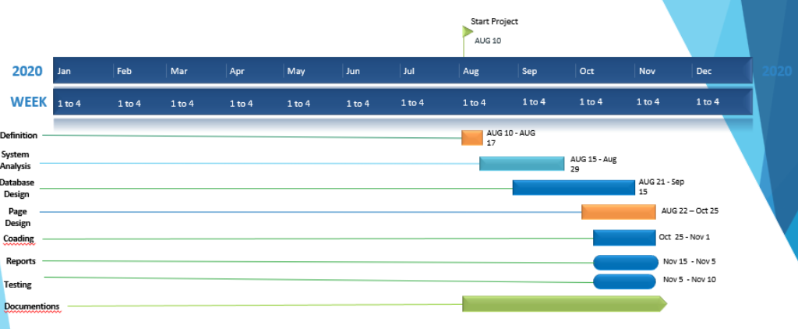

4

Department of Computer Application (MCA), SPCE, Visnagar

**3.FUNCTIONAL SPECIFICATION**

**3.1 Introduction**

**3.1.1. Purpose**

This website is used to the buying and selling of goods or services using the internet, and the transfer of money and data to execute these transactions,

**3.1.2. Scope**

**Admin:-**

* Log in
* Add products
* View products
* Manage carts
* Manage orders

**user:-**

* Register
* Log in
* Search products
* View products
* Add to cart
* Make orders
* Pay bills

5

Department of Computer Application (MCA), SPCE, Visnagar

**3.2 General Description**

**3.2.1. Functional Description**

* **Admin :-**

View, insert, update, or delete record of admin.

* **User :-**

View, insert, update, or delete record of any product in cart.

Department of Computer Application (MCA), SPCE, Visnagar

6

**3.2.2. User Characteristics**

**Admin:-**

Admin is a top level person who is responsible for that site management and has keen watch on the site movements. Admin can add Product View all orders and Payment Activity.

**User:-**

User as well as customer is second level person who can Search and view Products and make order. It can manage cart items

7

Department of Computer Application (MCA), SPCE, Visnagar

**4.HARDWARE & SOFTWARE SPECIFICATION**

**4.1 Hardware Requirement:-**

* PROCESSOR : Intel Core i3
* RAM : 4GB(recommended)
* HARD-DISK : 500GB(recommended)
* WINDOWS : WINDOWS 10

**4.2 Software Requirement:-**

* FRONT END TOOL : python 3.8
* BACK END TOOL : MySQL 5.0
* FRAMEWORK : Django 3.1
* CODE EDITOR : VS(visual studio) code editor
* OTHER TOOLS : MS Word 2016 MS PowerPoint 2016

8

Department of Computer Application (MCA), SPCE, Visnagar

**5. Detailed Design**

**5.1 Data Dictionary**

**1)auth user :-**

Table name: auth_user

Description: this is user as well as customer table .it’s a user authontication table

Primary key: id

Foreign key :

|  |  |  |  |  |  |
| --- | --- | --- | --- | --- | --- |
| SR.NO | Field Type | Data Type | Size | Constraints | Description |
| 1 | Id | Int | 11 | Primary key | User id |
| 2 | Password | Varchar | 128 | Not null | User password |
| 3 | Last_login | Datetime | 6 | Not null | Last log in date |
| 4 | Is_superuser | Tinyint | 1 | Not null | Check superuser |
| 5 | Username | Varchar | 150 | Unique key | Username use to log in |
| 6 | First_name | Varchar | 30 | Not null | User first name |
| 7 | Last_name | Varchar | 150 | Not null | User last name |
| 8 | Email | Varchar | 254 | Not null | User e-mail address |
| 9 | Is_staff | Tinyint | 1 | Not null | Chack the user is staff |
| 10 | Is_active | Tinyint | 1 | Not null | Check user is active |
| 11 | Date_joined | Datetime | 6 | Not null | User added time |

9

Department of Computer Application (MCA), SPCE, Visnagar

**2) contact:-**

Table name: contact

Description: this is contact us table .it’s a use to store the contact us details

Primary key: cid

Foreign key :

|  |  |  |  |  |  |
| --- | --- | --- | --- | --- | --- |
| SR.NO | Field Type | Data Type | Size | Constraints | Description |
| 1 | cid | Int | 11 | Primary key | Contact id |
| 2 | Fullname | Varchar | 255 | Not null | User full name |
| 3 | Subject | Varchar | 50 | Not null | Subject detail |
| 4 | Cemail | Varchar | 10 | Not null | User email |
| 5 | Msg | Longtext | - | Not null | Message |
| 6 | Timestamp | Datetime | 6 | Not null | Added time |

10

Department of Computer Application (MCA), SPCE, Visnagar

**3) products:-**

Table name: products

Description: this is products table .it’s a use to showing searching and fetching the products

Primary key: product_id

Foreign key :category_id, subcategory_id

|  |  |  |  |  |  |
| --- | --- | --- | --- | --- | --- |
| SR.NO | Field Type | Data Type | Size | Constraints | Description |
| 1 | product_id | Int | 11 | Primary key | It’s product id |
| 2 | title | Varchar | 50 | Not null | Product title |
| 3 | price | Int | 11 | Not null | Product price |
| 4 | sell_price | Decimal | 5.2 | *NULL* | Product sell price |
| 5 | Category_id | int | 11 | Foreign Key | Product category |
| 6 | description | Varchar | 300 | Not null | Product description |
| 7 | slug | Varchar | 50 | *NULL* | Product slug as tltle |
| 8 | pub_date | date | - | Not null | Product published date |
| 9 | active | Tinyint | 1 | Not null | Check product is available or not |
| 10 | subcategory_id | Int | 11 | Foreign Key | Product sub category |

11

Department of Computer Application (MCA), SPCE, Visnagar

**4) Category:-**

Table name: Category

Description: this is Category table .it’s a use to Categorised the products

Primary key: category_id

Foreign key :

|  |  |  |  |  |  |
| --- | --- | --- | --- | --- | --- |
| SR.NO | Field Type | Data Type | Size | Constraints | Description |
| 1 | category_id | int(11) | 11 | *Primary key* | Category id |
| 2 | Title | varchar(128) | 128 | Not null | Category title |
| 3 | description | varchar(300) | 300 | Not null | Category description |
| 4 | Slug | varchar(50) | 50 | *NULL* | Category slug |
| 5 | thumbnail | tinyint(1) | 1 | Not null | Check thumbnail |
| 6 | active | tinyint(1) | 1 | Not null | Check Category active |
| 7 | timestamp | datetime(6) | 6 | Not null | Category added time |

12

Department of Computer Application (MCA), SPCE, Visnagar

**5)SubCategory**

Table name: SubCategory

Description: this is SubCategory table .it’s a use to define subcategory of the products

Primary key: category_id

Foreign key :

|  |  |  |  |  |  |
| --- | --- | --- | --- | --- | --- |
| SR.NO | Field Type | Data Type | Size | Constraints | Description |
| 1 | subcategory_id | int(11) | 11 | *Primary key* | SubCategory id |
| 2 | title | varchar(128) | 128 | Not null | SubCategory title |
| 3 | description | varchar(300) | 300 | Not null | SubCategory description |
| 4 | slug | varchar(50) | 50 | *NULL* | SubCategory slug |
| 5 | thumbnail | tinyint(1) | 1 | Not null | Check thumbnail |
| 6 | active | tinyint(1) | 1 | Not null | Check SubCategory active |
| 7 | timestamp | datetime(6) | 6 | Not null | SubCategory added time |

13

Department of Computer Application (MCA), SPCE, Visnagar

**6) productsImages:-**

Table name: productsImages

Description: this is product images table .it’s a use to store the products images

Primary key: id

Foreign key :product_id

|  |  |  |  |  |  |
| --- | --- | --- | --- | --- | --- |
| SR.NO | Field Type | Data Type | Size | Constraints | Description |
| 1 | id | Int | 11 | Primary key | ProductsImages Id |
| 2 | Image | Varchar | 100 | Not null | Product Images url |
| 3 | Featured | Tinyint | 1 | Not null | Product fratured |
| 4 | Active | Tinyint | 1 | Not null | Check the Product is active |
| 5 | Timestamp | Datetime | 6 | Not null | Product Added time |
| 6 | product_id | Int | 11 | Foreign Key | Product id |

14

Department of Computer Application (MCA), SPCE, Visnagar

**7) UserCart:-**

Table name: UserCart

Description: this is user as well as customer table .it’s a user authentication table

Primary key: id

Foreign key : cart_id, product_id

|  |  |  |  |  |  |
| --- | --- | --- | --- | --- | --- |
| SR.NO | Field Type | Data Type | Size | Constraints | Description |
| 1 | id | Int | 11 | *Primary key* | Cart items id |
| 2 | quantity | Int | 11 | Not null | Product quantity |
| 3 | Payment_status | Tinyint | 1 | Not null | Totle products price |
| 4 | added_on | Datetime | 6 | Not null | Product Added time |
| 5 | updated | Datetime | 6 | Not null | Cart updated time |
| 6 | owner_id | Int | 11 | Foreign Key | Which user cart |
| 7 | product_id | Int | 11 | Foreign Key | Product id |

15

4

Department of Computer Application (MCA), SPCE, Visnagar

**8) UserOrder :-**

Table name: order

Description: this is order table .it’s a use to store order information

Primary key: id

Foreign key :

|  |  |  |  |  |  |
| --- | --- | --- | --- | --- | --- |
| SR.NO | Field Type | Data Type | Size | Constraints | Description |
| 1 | Order_id | Int | 11 | *Primary key* | order id |
| 2 | first_name | Varchar | 90 | Not null | Order Owner first name |
| 3 | last_name | Varchar | 90 | Not null | Order Owner last name |
| 4 | State | Varchar | 111 | Not null | Order Owner state |
| 5 | Address | Varchar | 111 | Not null | Order Owner address |
| 6 | address2 | Varchar | 111 | Null | Order Owner address 2 |
| 7 | City | Varchar | 111 | Not null | Order Owner city |
| 8 | Zip_code | Varchar | 111 | Not null | Order Owner zip_code |
| 9 | Phone | Varchar | 111 | Not null | Order Owner contact number |
| 10 | Email | Varchar | 111 | Not null | Order Owner email |
| 11 | Amount | int | 10 | Not null | Totle order amount |

16

Department of Computer Application (MCA), SPCE, Visnagar

**5.2 Entity Relationship Diagram**

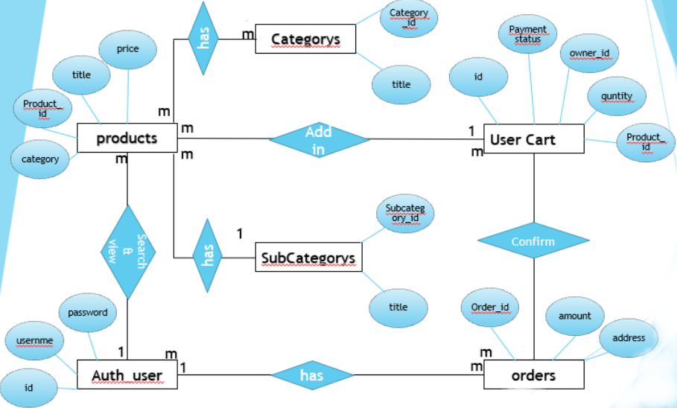

17

Department of Computer Application (MCA), SPCE, Visnagar

**5.3 UML Diagrams**

**5.3.1 USE CASE DIAGRAM**

**ADMIN:-**

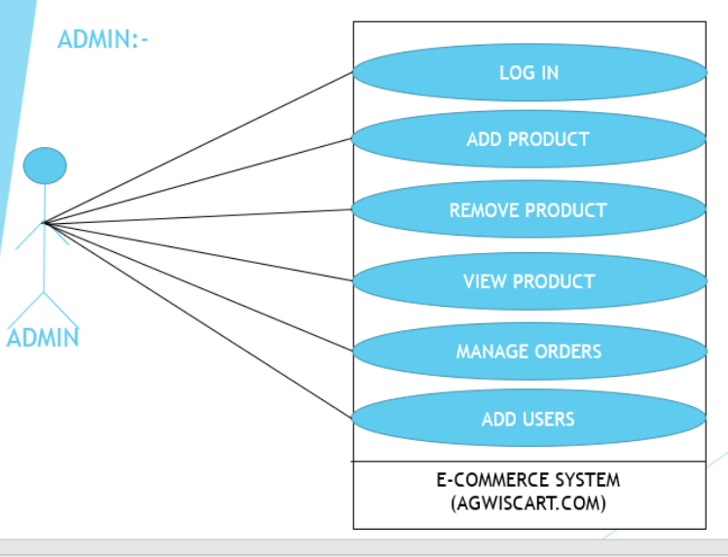

18

Department of Computer Application (MCA), SPCE, Visnagar

**USERS(CUSTOMER):-**

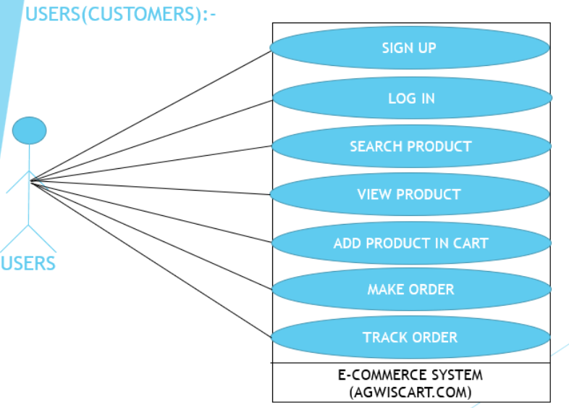

19

Department of Computer Application (MCA), SPCE, Visnagar

**5.3.2 CLASS DIAGRAM**

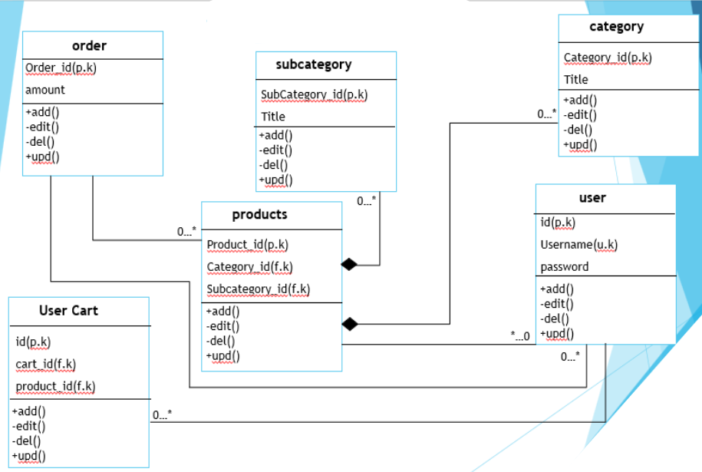

20

Department of Computer Application (MCA), SPCE, Visnagar

**5.3.3 SEQUENCE DIAGRAM**

**Admin:-**

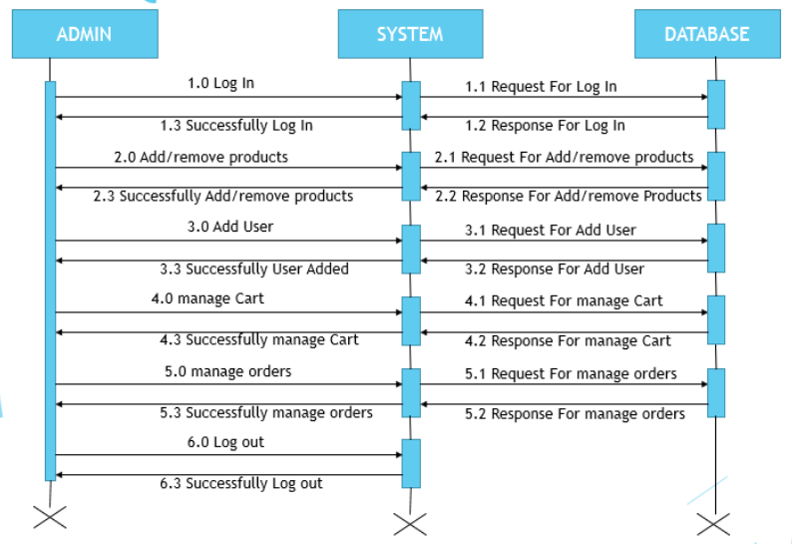

21

Department of Computer Application (MCA), SPCE, Visnagar

**User:-**

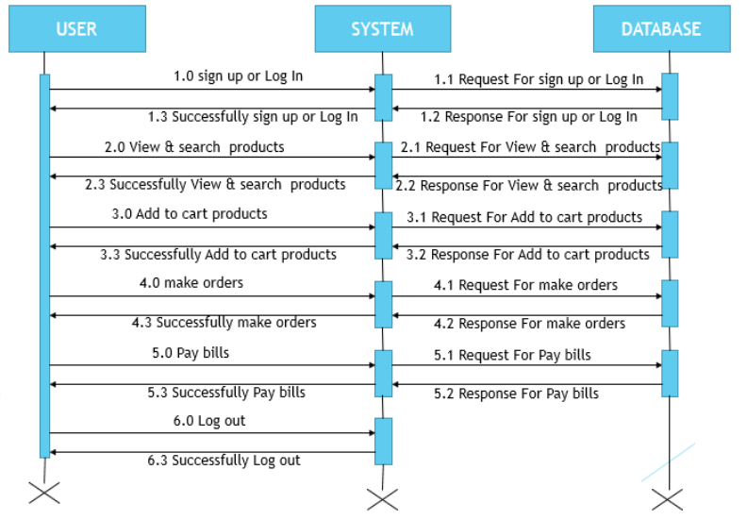

22

Department of Computer Application (MCA), SPCE, Visnagar

**5.3.4 ACTIVITY DIAGRAM**

**Admin :-**

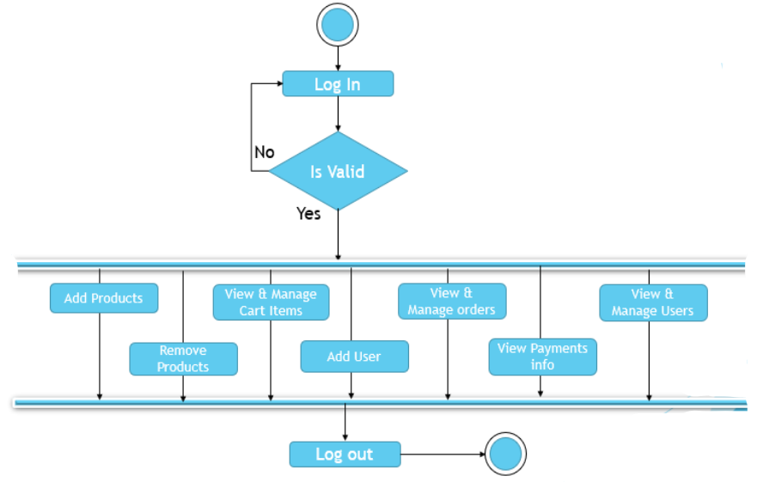

23

Department of Computer Application (MCA), SPCE, Visnagar

**User :-**

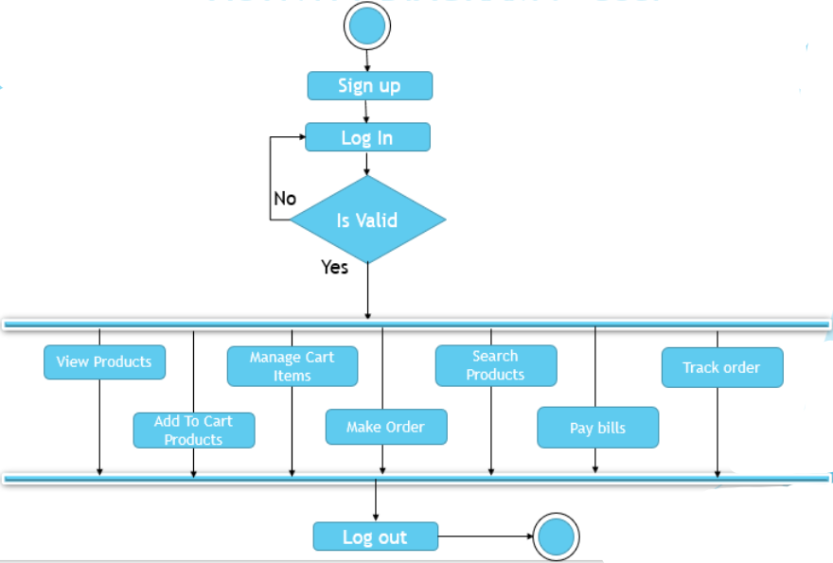

24

Department of Computer Application (MCA), SPCE, Visnagar

**6. Input & Output Designing**

**6.1 Admin Side Design**

**Login page:-** this page is admin login page

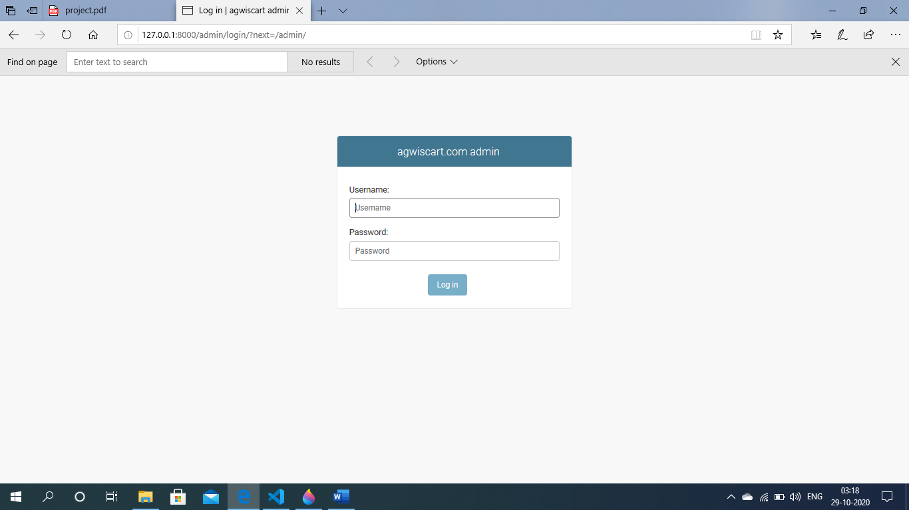

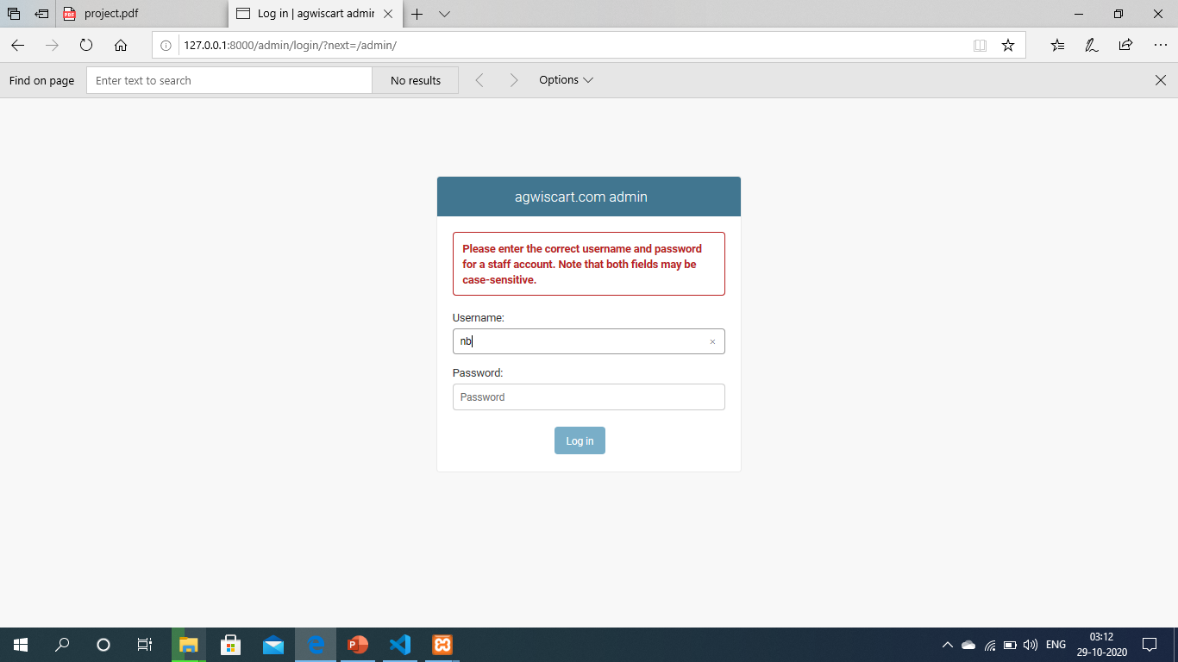

25

Department of Computer Application (MCA), SPCE, Visnagar

**Admin home page:-**

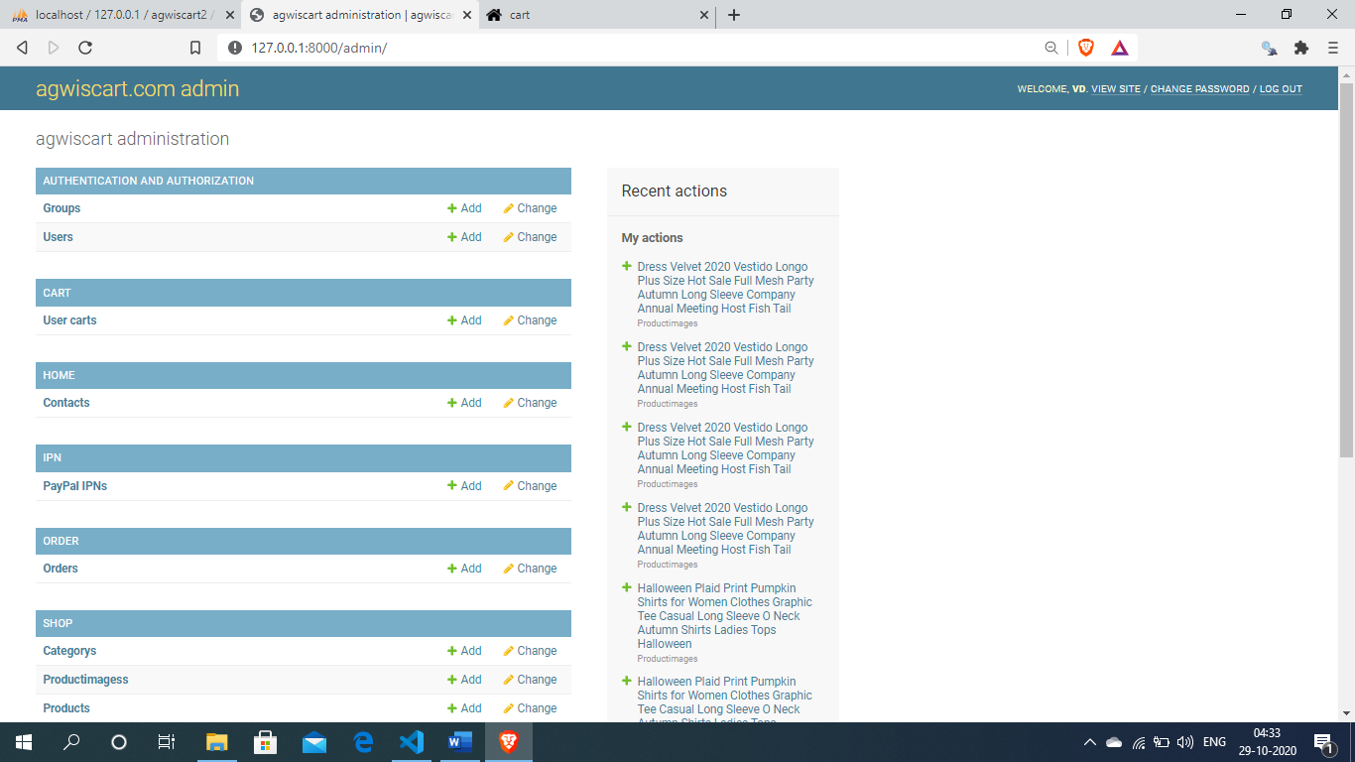

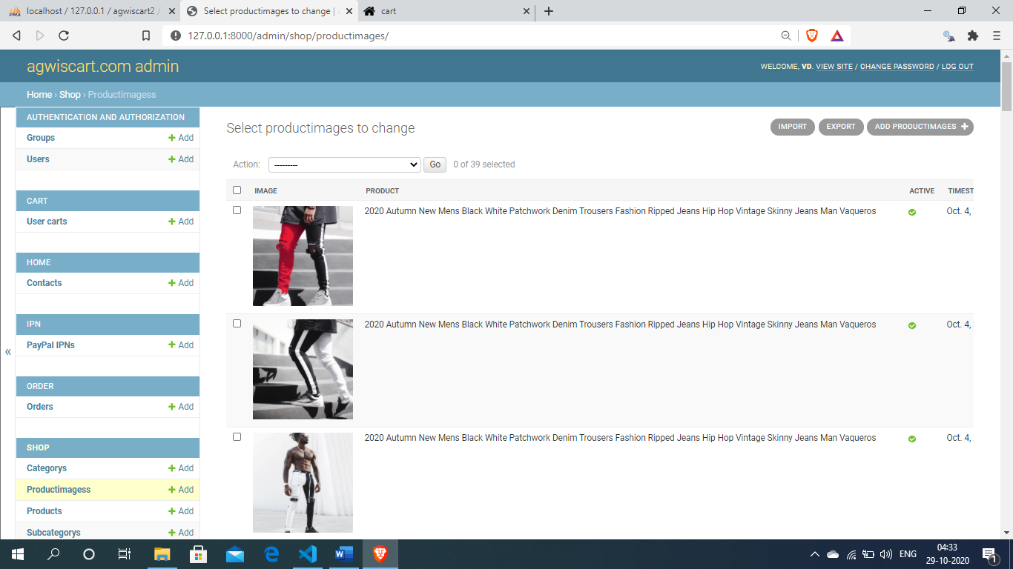

26

Department of Computer Application (MCA), SPCE, Visnagar

**Admin add products :-**

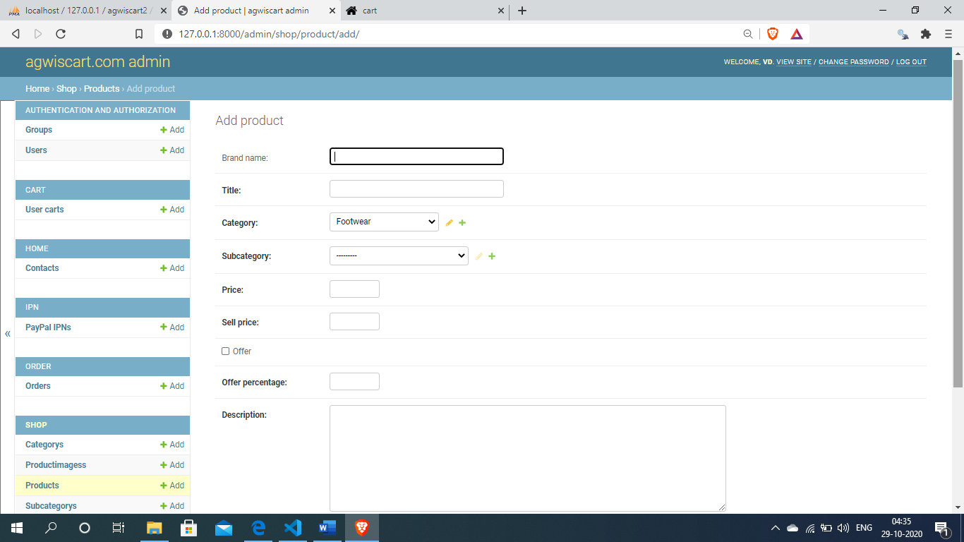

**View products :-**

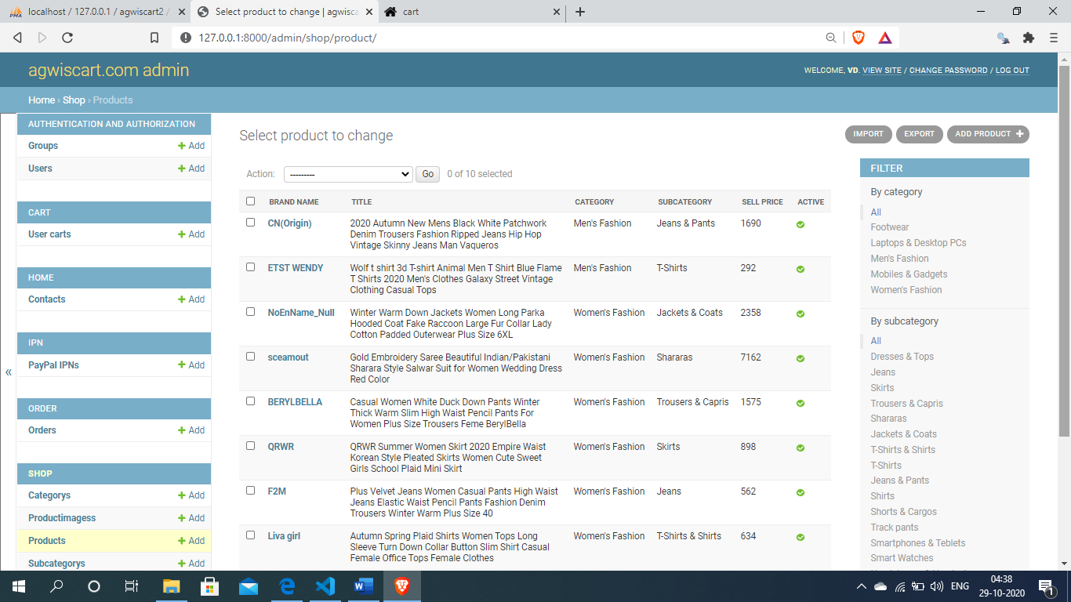

27

Department of Computer Application (MCA), SPCE, Visnagar

**6.2 User side design**

**User home page:-**this page is agwiscart.com home page

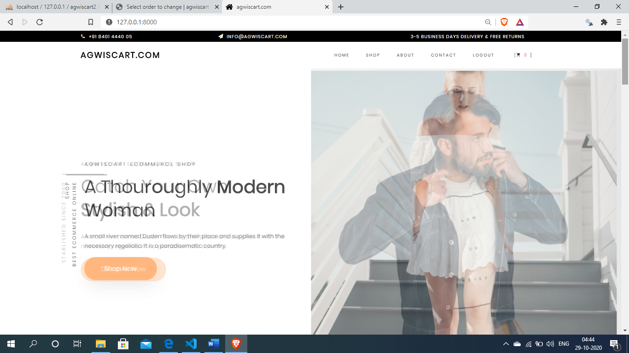

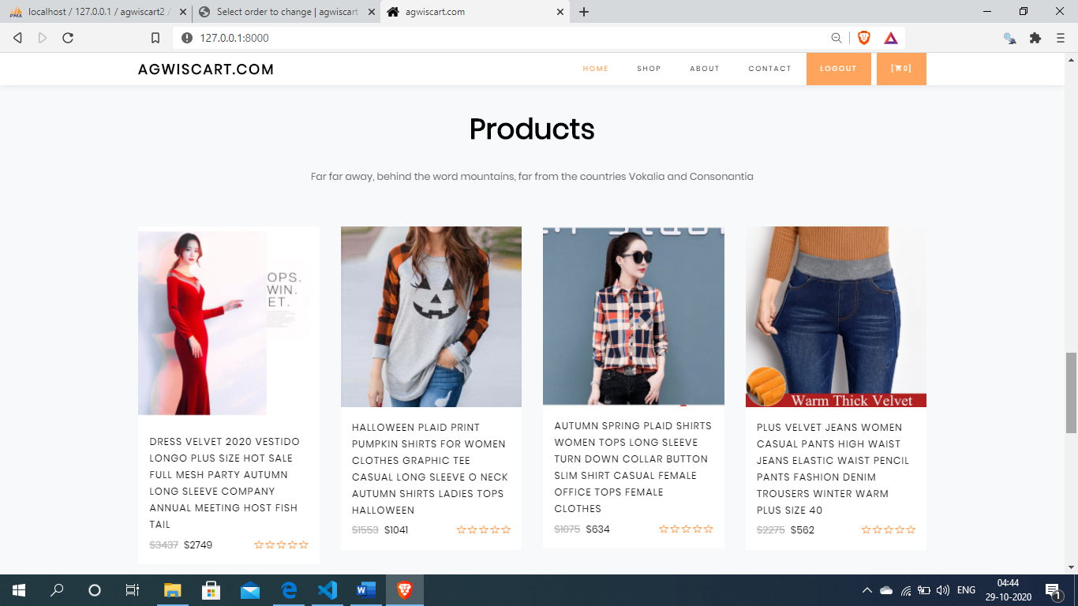

28

Department of Computer Application (MCA), SPCE, Visnagar

**Shop page:-**

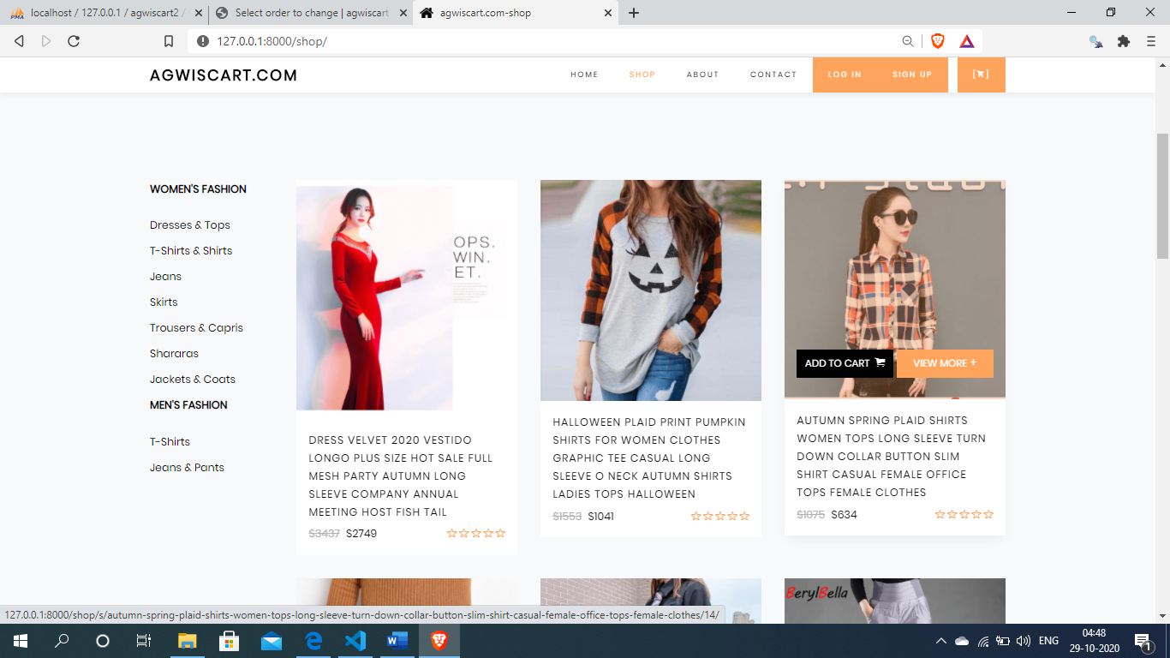

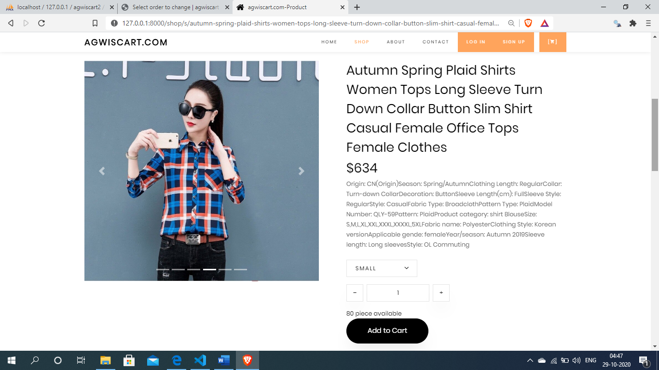

29

Department of Computer Application (MCA), SPCE, Visnagar

**About page :-**

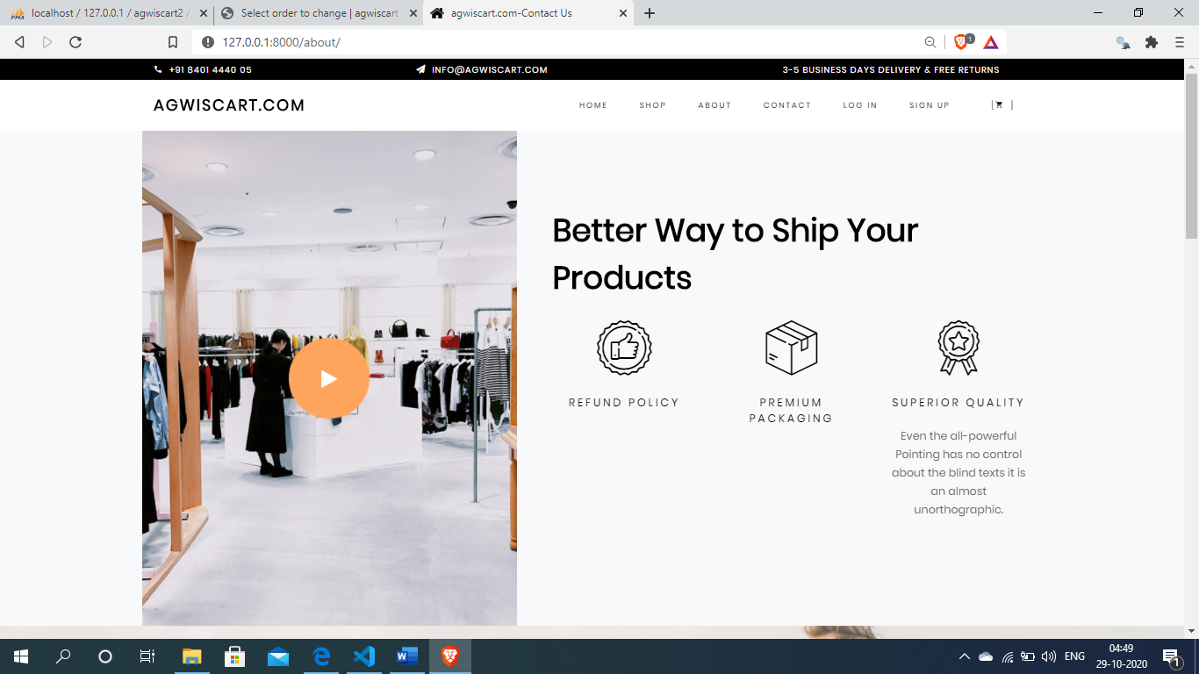

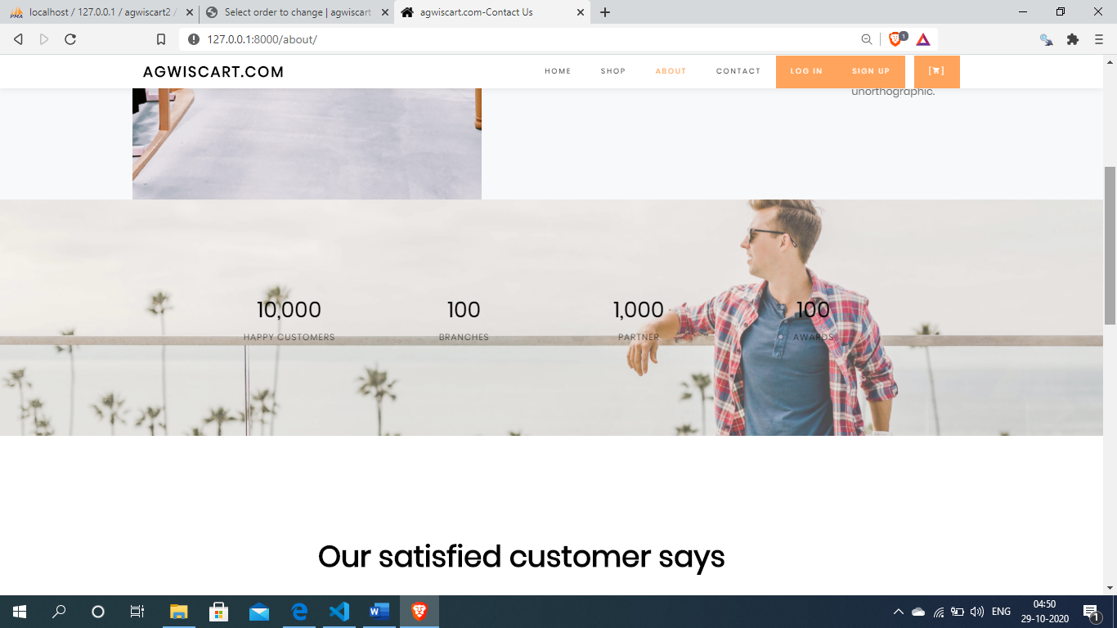

30

Department of Computer Application (MCA), SPCE, Visnagar

**Contact page:-**

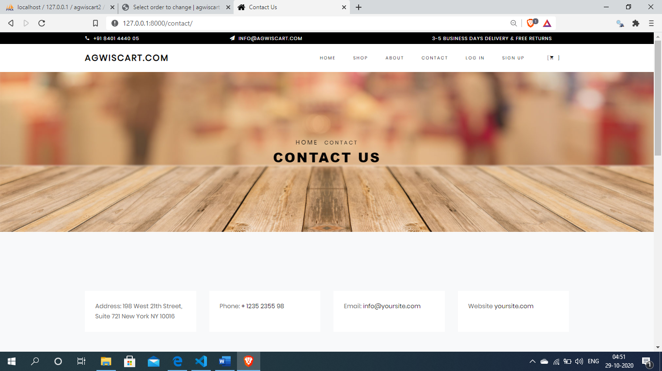

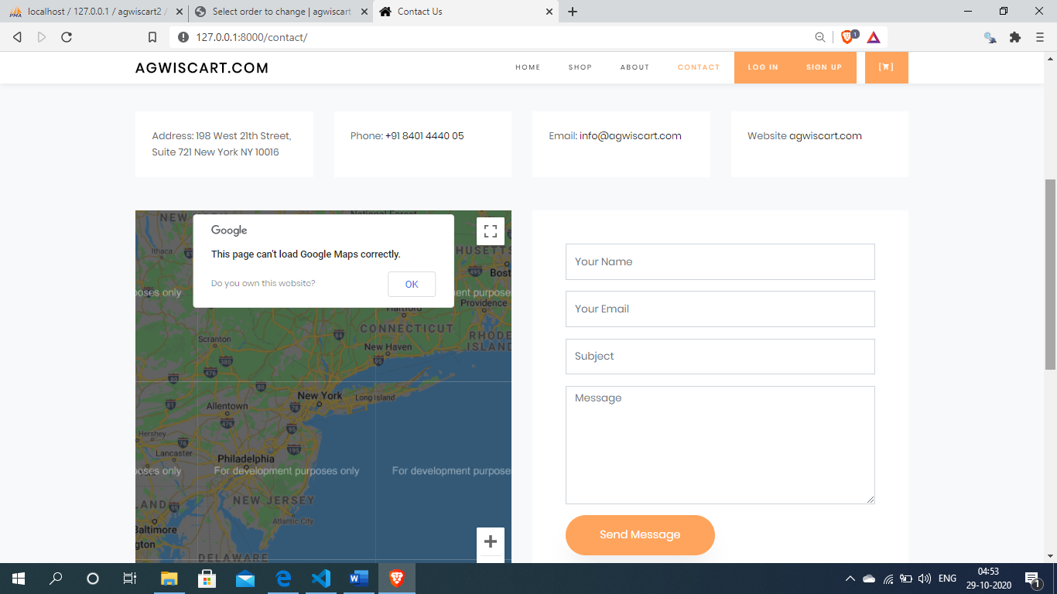

31

Department of Computer Application (MCA), SPCE, Visnagar

**User log in page:-**

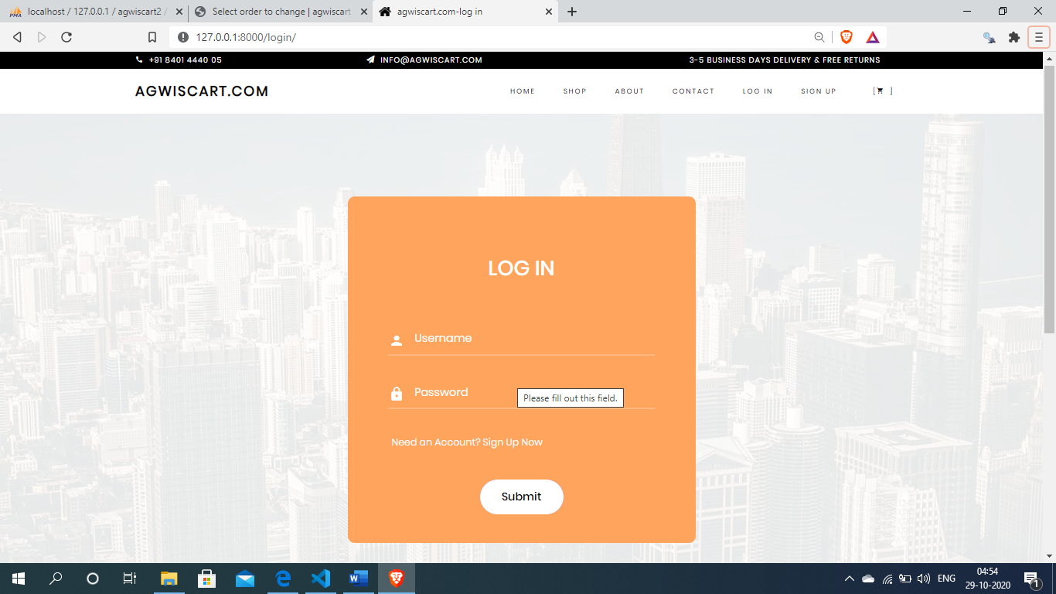

**User sign up page :-**

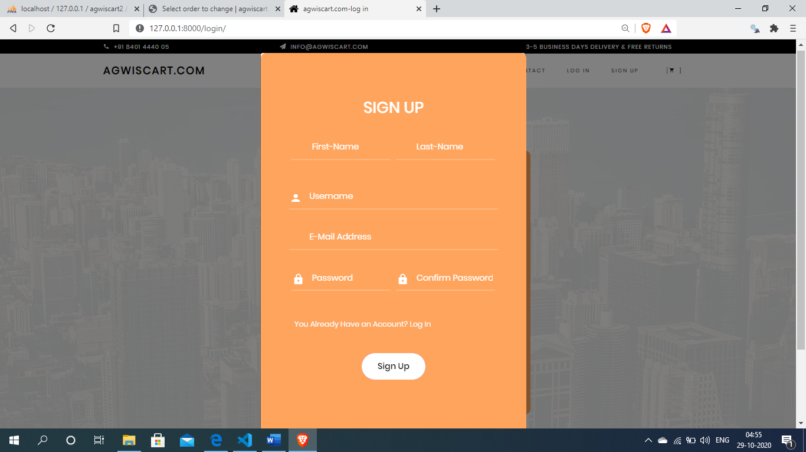

32

Department of Computer Application (MCA), SPCE, Visnagar

**Shopping cart page:-**

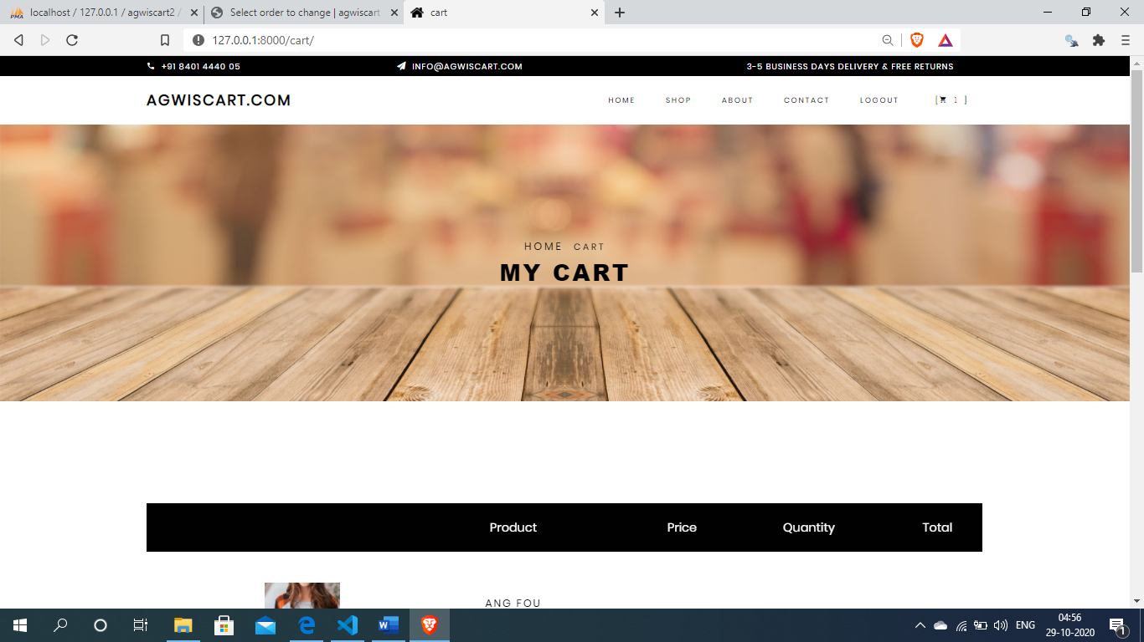

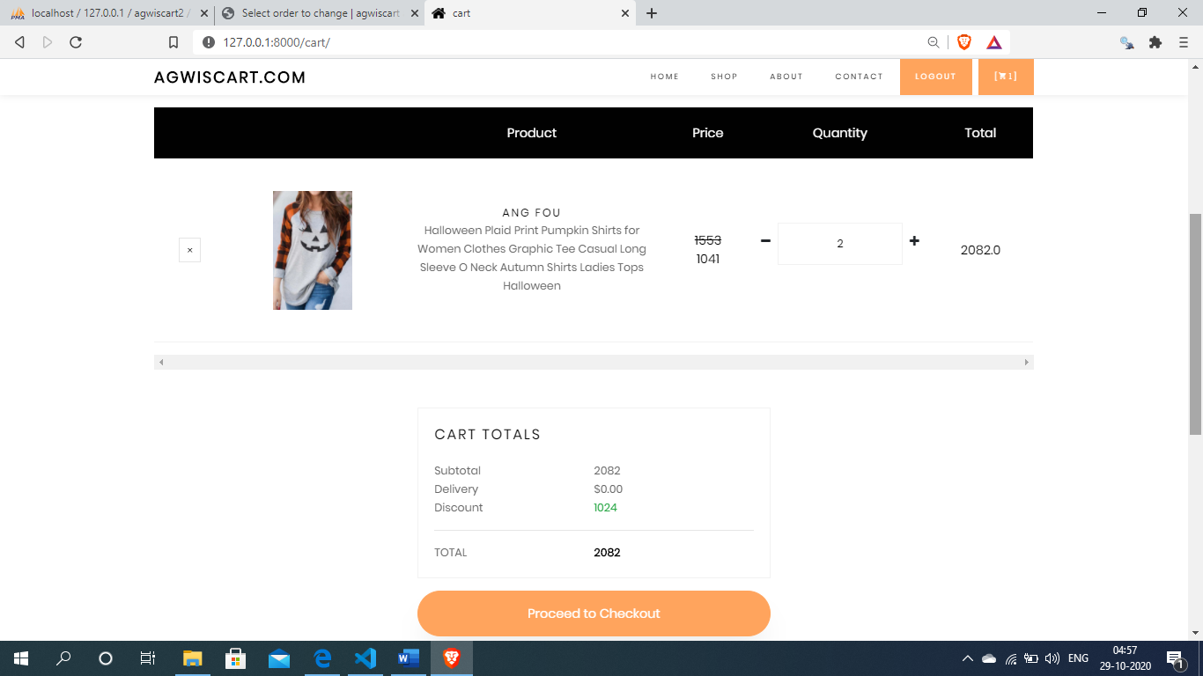

33

Department of Computer Application (MCA), SPCE, Visnagar

**User checkout page:-**

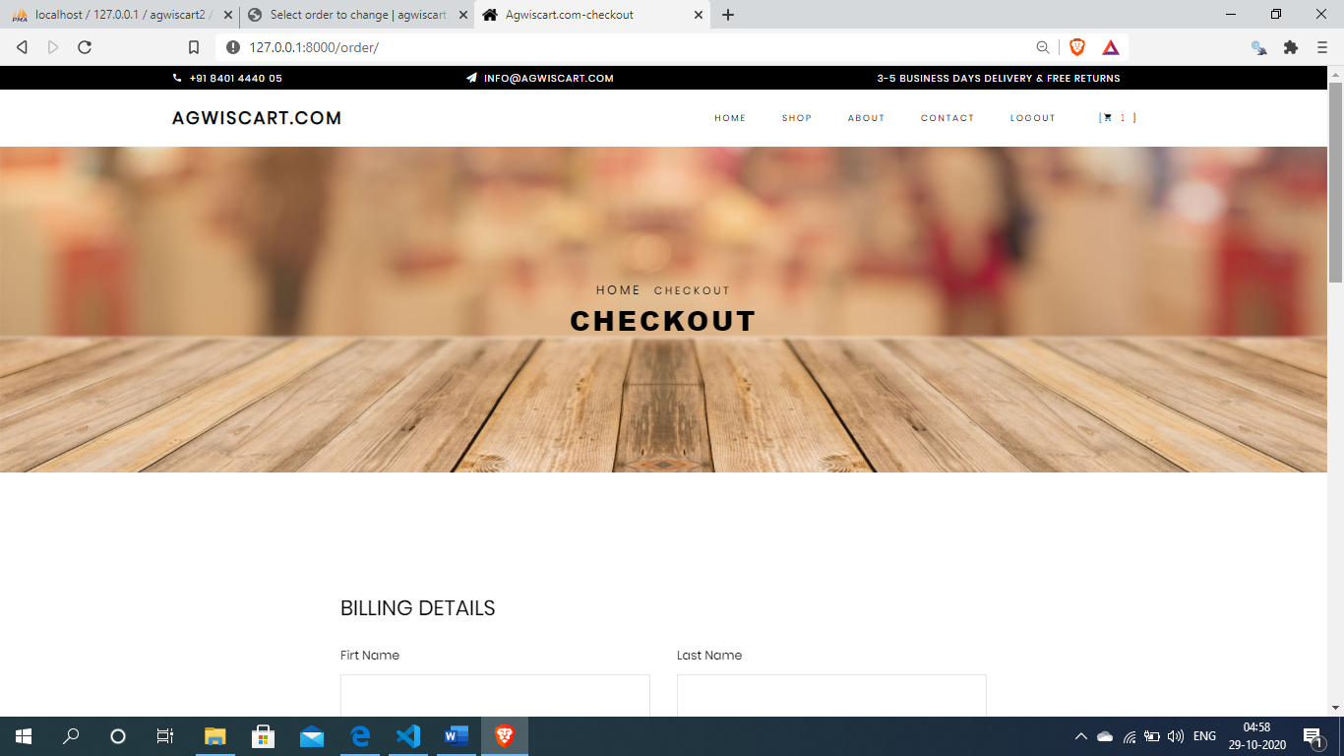

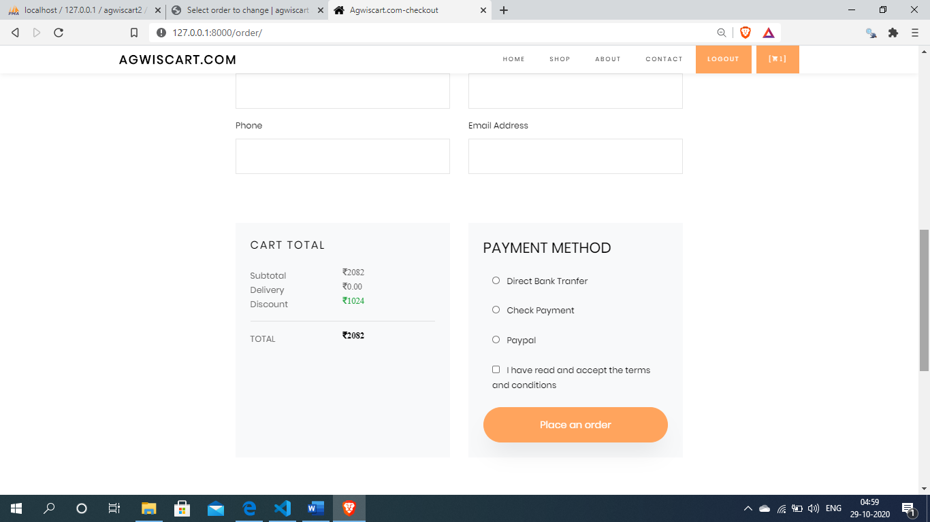

34

Department of Computer Application (MCA), SPCE, Visnagar

**Payments page:-**

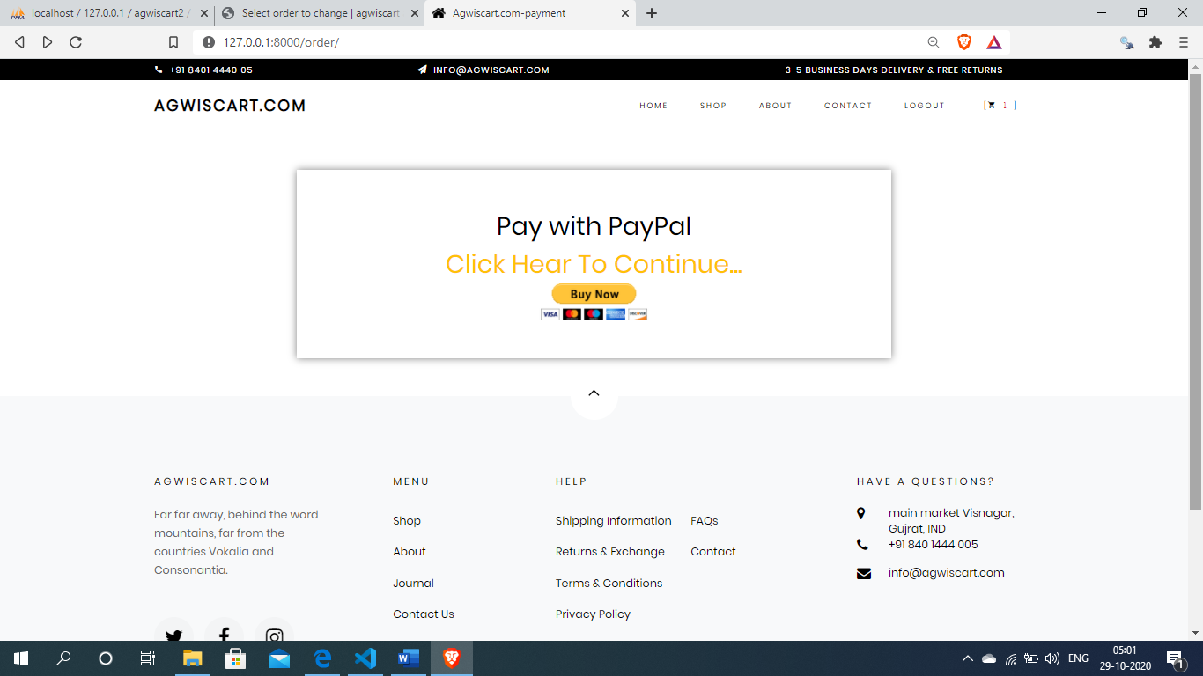

**After click the buy now button open payments gateway(paypal)**

**For pay the bills**

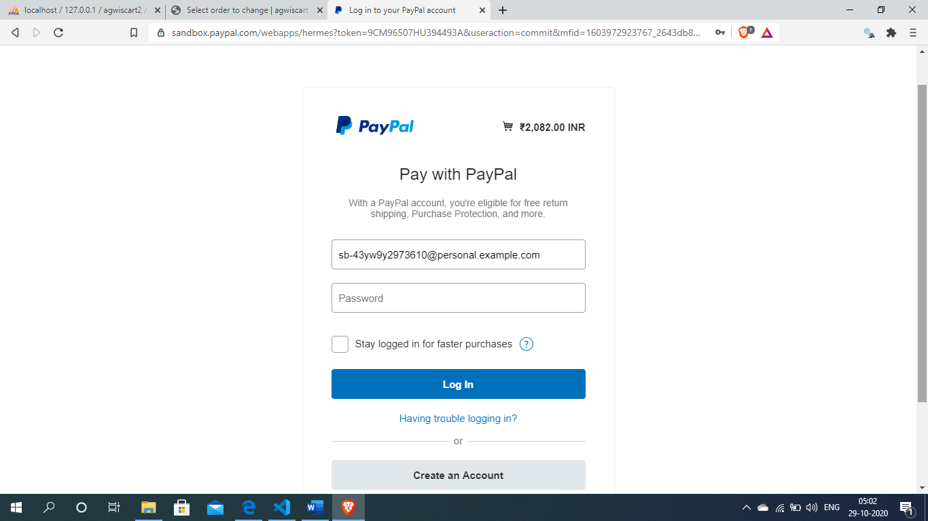

35

Department of Computer Application (MCA), SPCE, Visnagar

**7.TESTING & RESULT**

**7.1 Introduction**

**TESTING :-**

Software Testing has a dual function it is used to establish the presence of defects in program and it is used to help judge whether or not the program is usable in practice. Thus software testing is used for validation and verification, which ensure that software conforms to its specifications and meets the need of the software customer.

We have resorted Alpha testing, which usually comes in after the basic design of the program has been completed. The project scientist will look over the program and the suggestions and ideas to improve or to correct the design. They also report and give ideas to get rid of around any major problems. There is bound to be a number of bugs after a problem have been created.

36

Department of Computer Application (MCA), SPCE, Visnagar

**7.2 Test Cases**

**Admin Login Form :-**

|  |  |  |  |
| --- | --- | --- | --- |
| SI NO. | Test case | Expected Result | Test Result |
| 1 | Enter valid name and password & click on login button | Display main window | Success |
| 2 | Enter invalid name and password & click on login button | Does not display main window and show the error | Success |

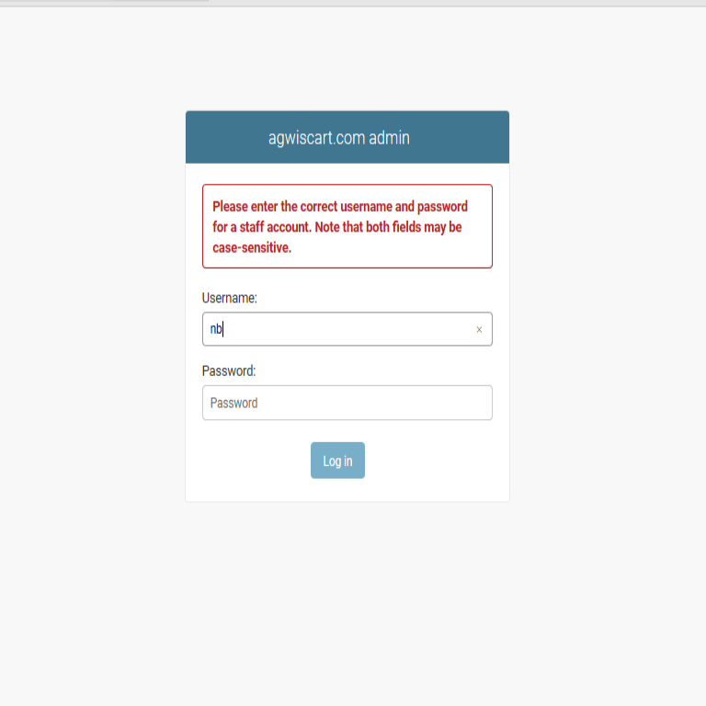

37

Department of Computer Application (MCA), SPCE, Visnagar

**Admin add products Form :-**

|  |  |  |  |
| --- | --- | --- | --- |
| SI NO. | Test case | Expected Result | Test Result |
| 1. | On the click of ADD PRODUCT button | At first user have to fill all fields with proper data , if any Error like entering text data instead of number or entering number instead of text..is found then it gives proper message otherwise Adds Record To the Database | Success |

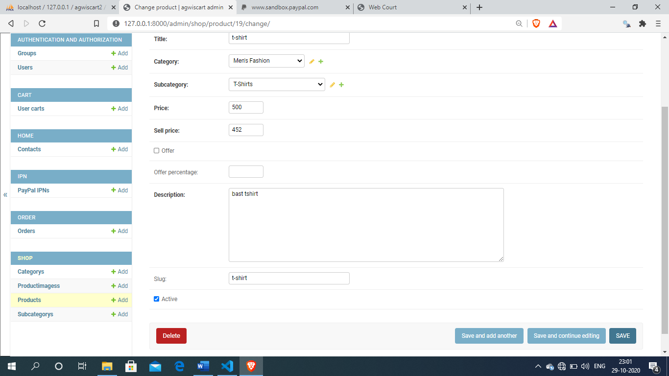

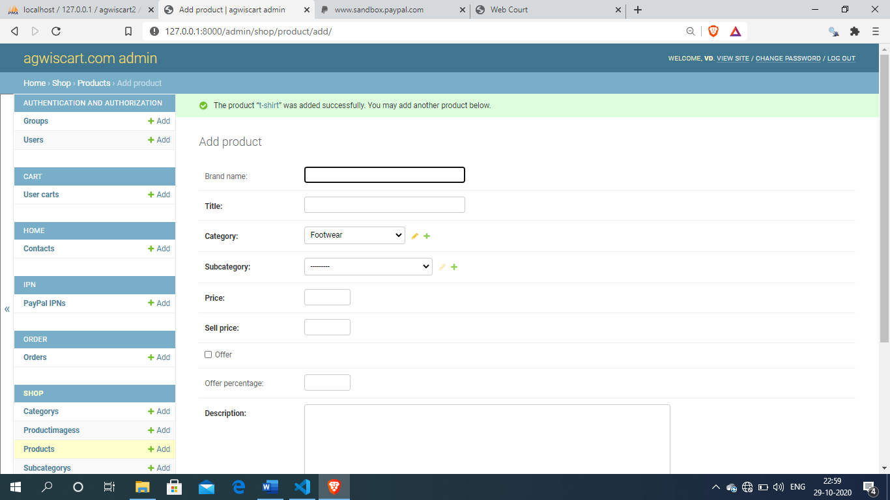

38

Department of Computer Application (MCA), SPCE, Visnagar

**User login form :-**

|  |  |  |  |
| --- | --- | --- | --- |
| SI NO. | Test case | Expected Result | Test Result |
| 1 | Enter valid name and password & click on login button | User can add products in cart and create own cart. User can checkout and pay bills and make orders | Success |
| 2 | Enter invalid name and password & click on login button | User does not can add products in cart and does not create own cart. User does not can checkout and pay bills and does not make orders | Success |

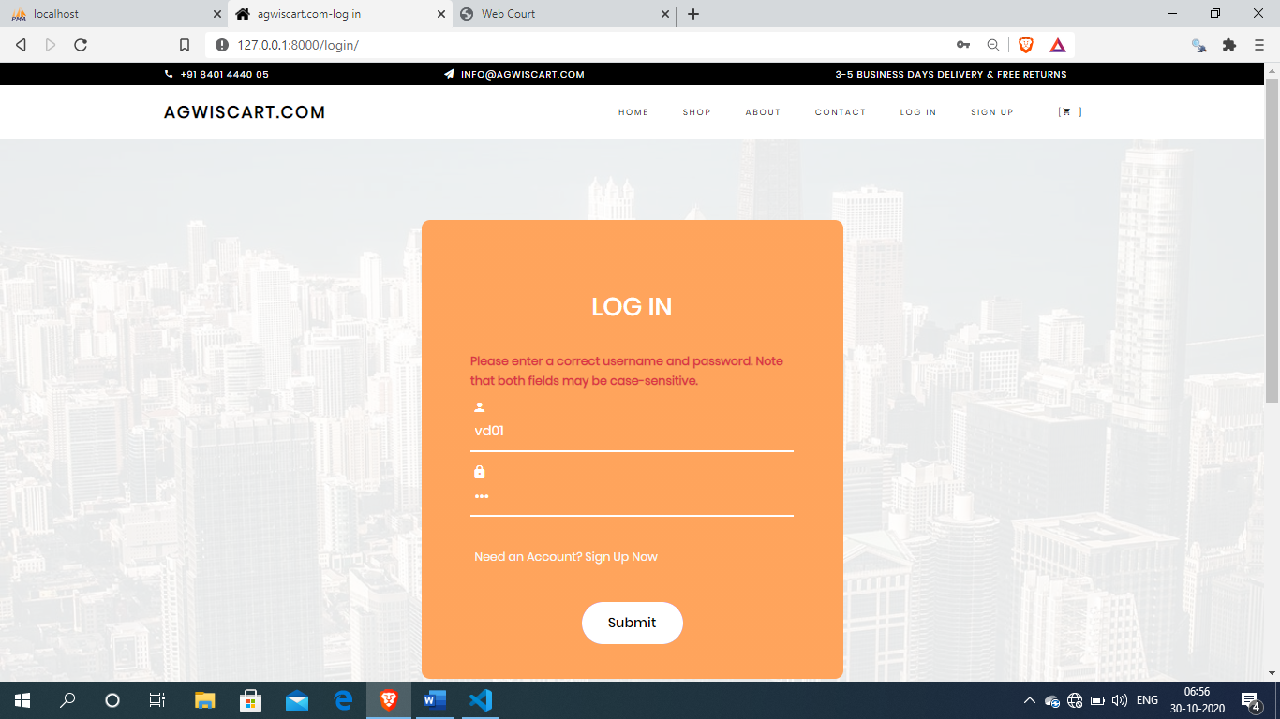

39

Department of Computer Application (MCA), SPCE, Visnagar

**User add product in cart :-**

|  |  |  |  |
| --- | --- | --- | --- |
| SI NO. | Test case | Expected Result | Test Result |
| 1. | On the click of ADD TO CART button | Add product in cart | Success |

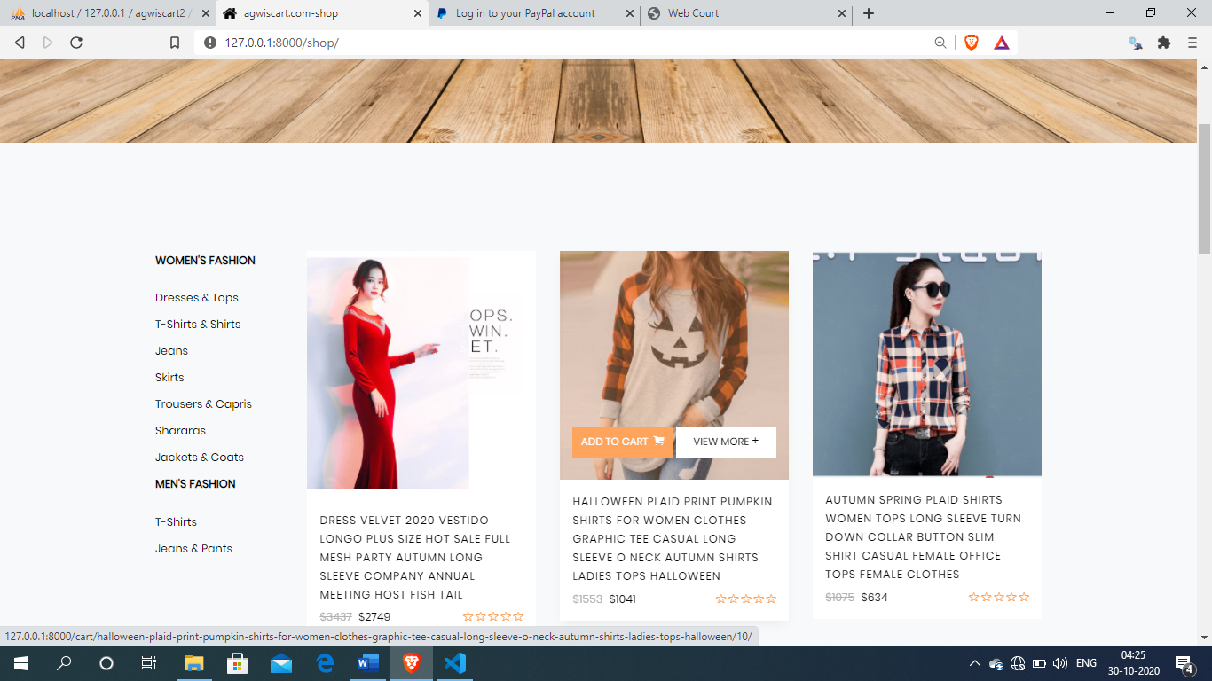

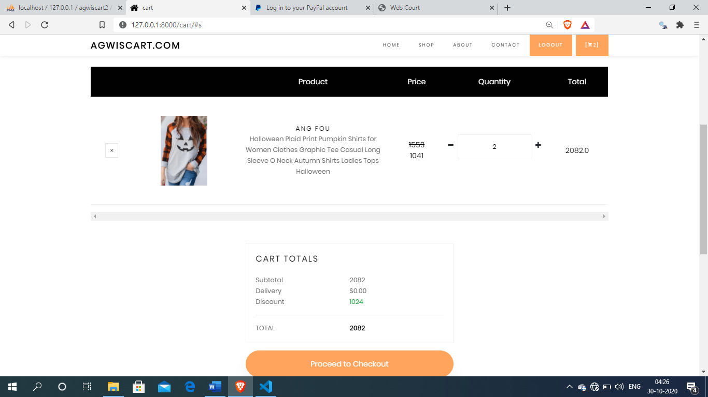

40

Department of Computer Application (MCA), SPCE, Visnagar

**User manage products quantity in cart:-**

|  |  |  |  |
| --- | --- | --- | --- |
| SI NO. | Test case | Expected Result | Test Result |
| 1. | On the click PLUS(+) button | Add product quantity in cart also added from database . and manage the total price of cart items | Success |
| 2 | On the click MINUS(-) button | Minus product quantity and if quantity is 0 than product automatically remove from cart . and manage the total price of cart items | Success |
| 3 | On the click remove button | Remove product from cart | Success |



41

Department of Computer Application (MCA), SPCE, Visnagar

**User make order:-**

|  |  |  |  |
| --- | --- | --- | --- |
| SI NO. | Test case | Expected Result | Test Result |
| 1. | On the click place an order button | At first user have to fill all fields with proper data , if any Error like entering text data instead of number or entering number instead of text..is found then it gives proper message otherwise Adds Record To the Database,pay bills and make order | Success |

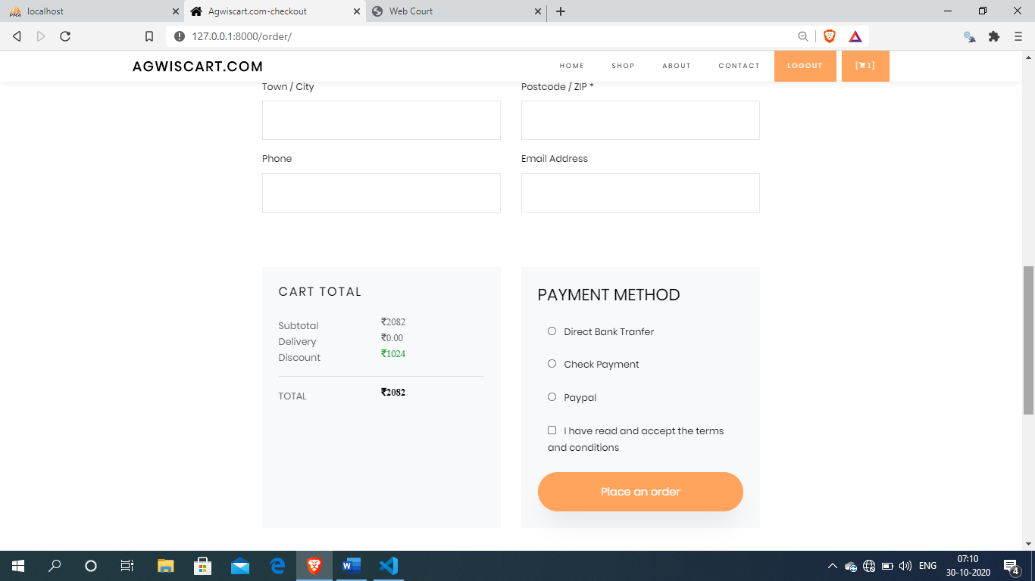

42

Department of Computer Application (MCA), SPCE, Visnagar

**8. LIMITATIONS & FUTURE SCOPE**

**8.1 Limitations**

* Limitation of this web site is available in only India.

**8.2 Future Scope**

* In the future can SMS & Email order details Facility can be implemented in this system.

43

Department of Computer Application (MCA), SPCE, Visnagar

**9. CONCLUSION**

**The conclusion is that:-**

* The shop owner can easily maintain the system as well as customer and order information.
* have the choice to shop ***online*** or make purchases in the traditional manner.
* ***Online*** ***shopping*** has increased and changed the way people shop.
* There is convince having the ability to shop from home. *With the introduction of internet ***shopping*** ***online*** has become popular. ***Shopping*** ***online*** allows access to merchandise sold world wide. It is a growing part of retail. ***Online*** ***shopping*** is time saving and convenient. There is often no cost for traveling when ordering items ***online***.

44

Department of Computer Application (MCA), SPCE, Visnagar

**10. REFERENCES**

**Web Sites References:-**

* <http://www.youtube.com>
* <http://www.javapoint.com>
* <https://docs.djangoproject.com/en/3.1/>
* <https://docs.python.org/3/>
* <https://pypi.org/>
* <https://getbootstrap.com/>
* <https://stackoverflow.com/>

45

Department of Computer Application (MCA), SPCE, Visnagar



46

Department of Computer Application (MCA), SPCE, Visnagar